Test out-of-order events:
First, in Swagger, execute POST /api/v1/roster/events with a new idempotency key:
X-Idempotency-Key: demo-batch-002
payload: {
"events": [
{
"event_id": "evt-demo-003",
"event_type": "UPDATE",
"employee_id": "EMP1001",
"source_version": 3,
"source_timestamp": "2026-10-31T12:00:00Z",
"first_name": "Aarav",
"last_name": "Sharma",
"email": "aarav.updated@example.com",
"office_code": "BLR_01",
"department": "Artificial Intelligence",
"status": "ACTIVE"
}
]
}
Response :
{
"tenant_id": "tenant-alpha",
"total_received": 1,
"accepted_count": 1,
"stale_count": 0,
"duplicate_count": 0,
"rejected_count": 0,
"results": [
{
"record_index": 0,
"employee_id": "EMP1001",
"status": "accepted",
"source_version": 3,
"message": "Employee updated successfully"
}
],
"errors": []
}
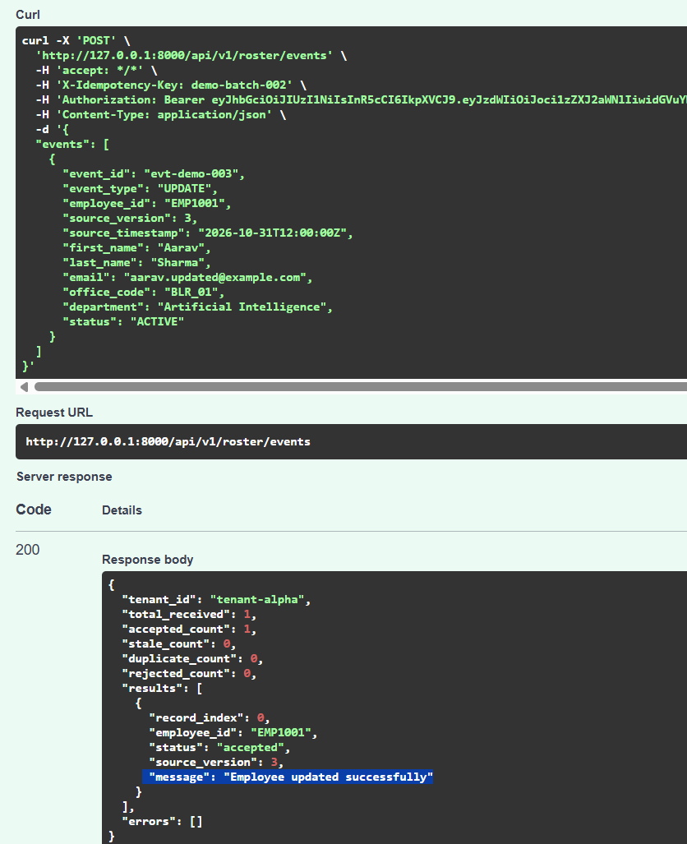

Now we'll verify that stale events cannot overwrite newer data.
In Swagger, execute the same endpoint with a new idempotency key:
X-Idempotency-Key: demo-batch-003
Request body:
{
"events": [
{
"event_id": "evt-demo-002",
"event_type": "UPDATE",
"employee_id": "EMP1001",
"source_version": 2,
"source_timestamp": "2026-10-31T11:00:00Z",
"first_name": "Aarav",
"last_name": "Sharma",
"email": "aarav.old@example.com",
"office_code": "BLR_01",
"department": "Operations",
"status": "ACTIVE"
}
]}
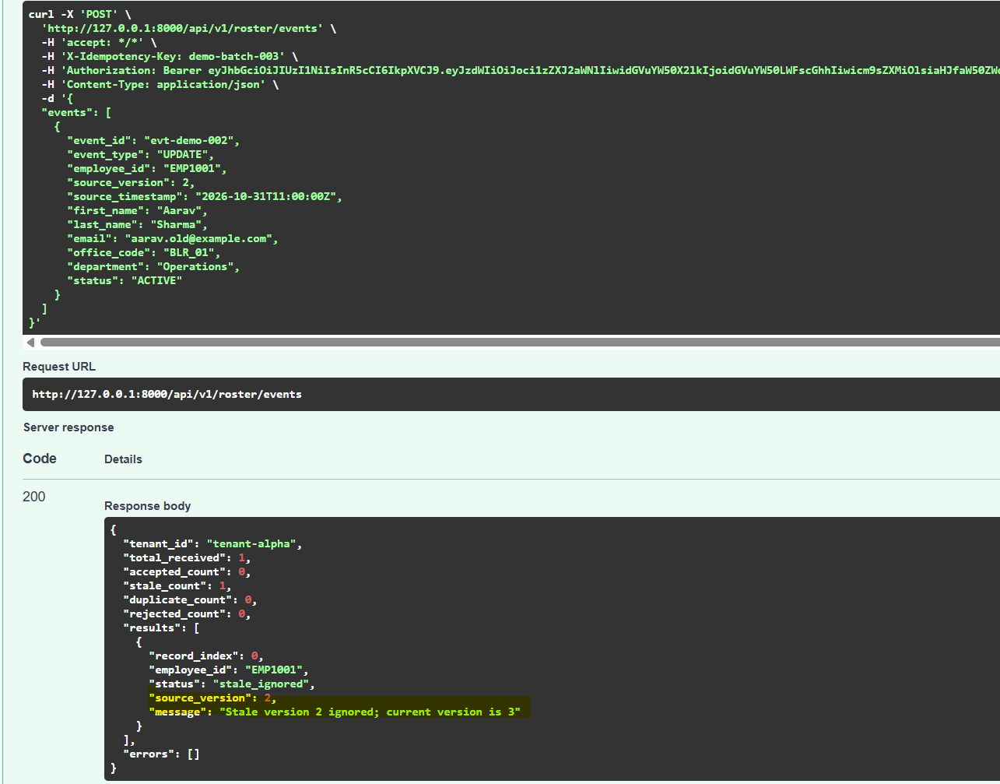

moveinsync_roster=# SELECT employee_id, email, department, office_code,source_version, status FROM employees WHERE employee_id = 'EMP1001';
employee_id | email | department | office_code | source_version | status
-------------+---------------------------+-------------------------+-------------+----------------+--------
EMP1001 | aarav.updated@example.com | Artificial Intelligence | BLR_01 | 3 | ACTIVE
(1 row)

moveinsync_roster=#
What we demonstrated: HR systems can deliver events out of order due to retries, network delays, or asynchronous processing. Your service uses source_version to prevent older events from overwriting newer employee data.

